**CREATE IBM WATSON IOT PLATFORM AND DEVICE**

Firstly create an IBM cloud account with IBMid and password

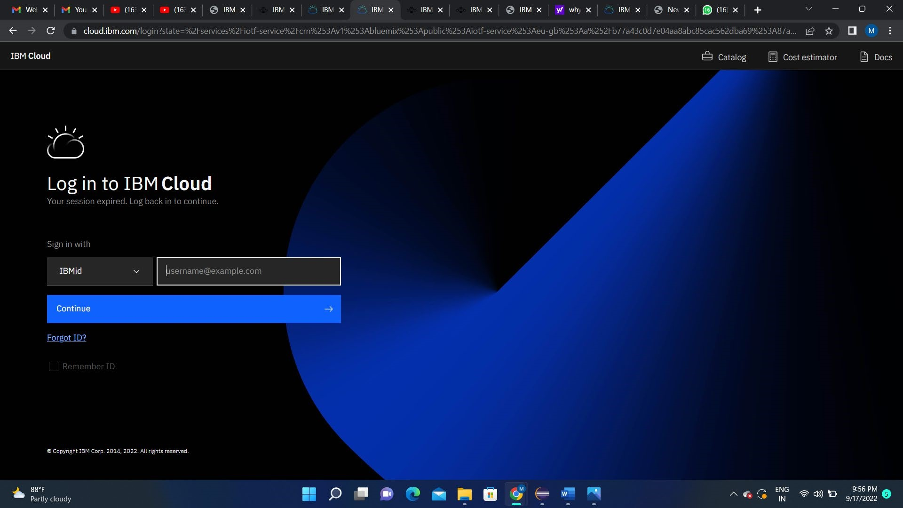

Home page of IBM cloud

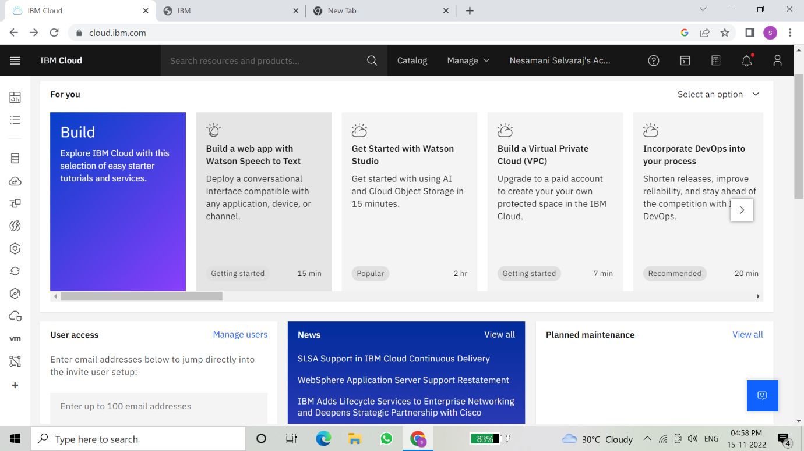

Click on the catalog on the top

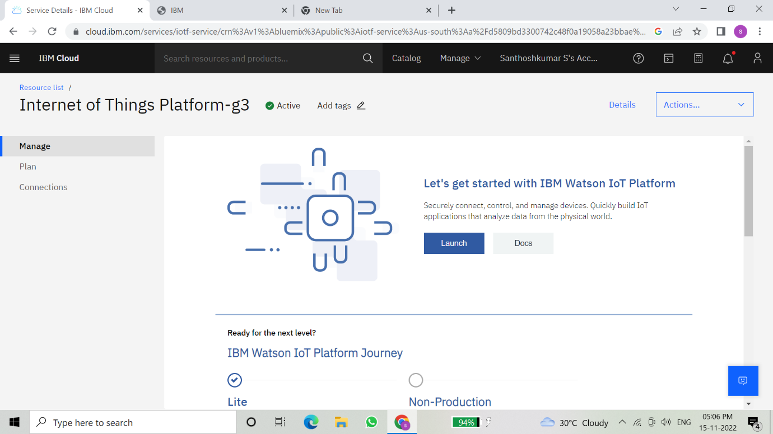

If already a lite is present delete it else u can’t create another

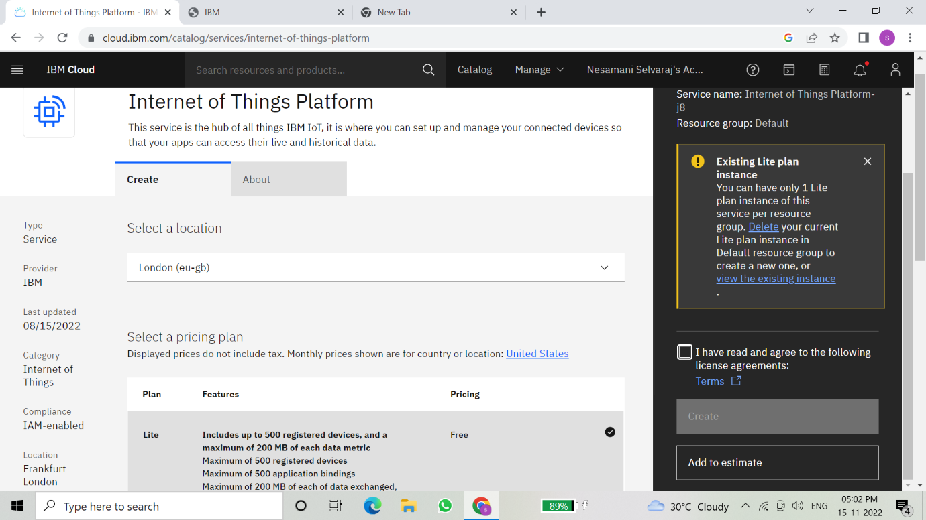

Clicking on the launch button in the manage tab, it will open to this

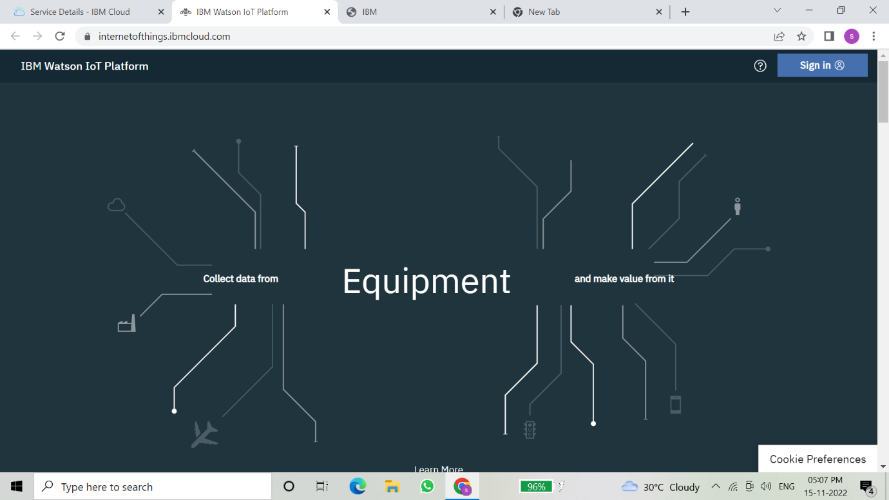

Once logged in the name will be displayed and it goes back to the first page

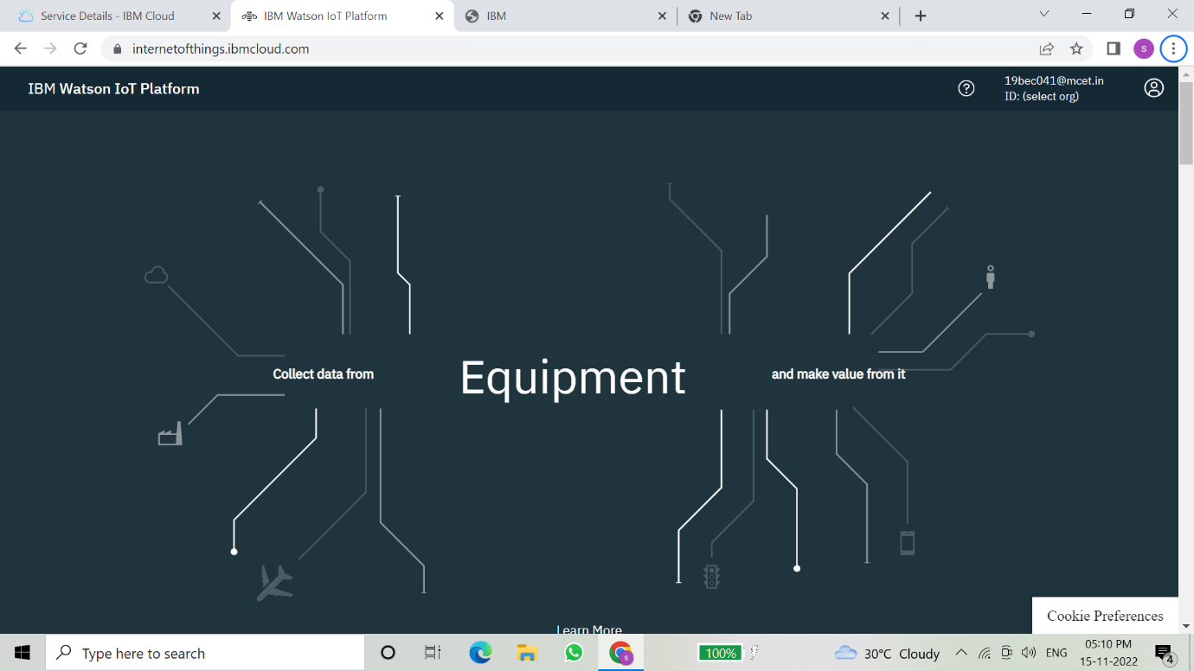

And again clicking on the launch button will open this tab, the device will help in the creation of the devices, the addition of devices, and the display of details of the devices.

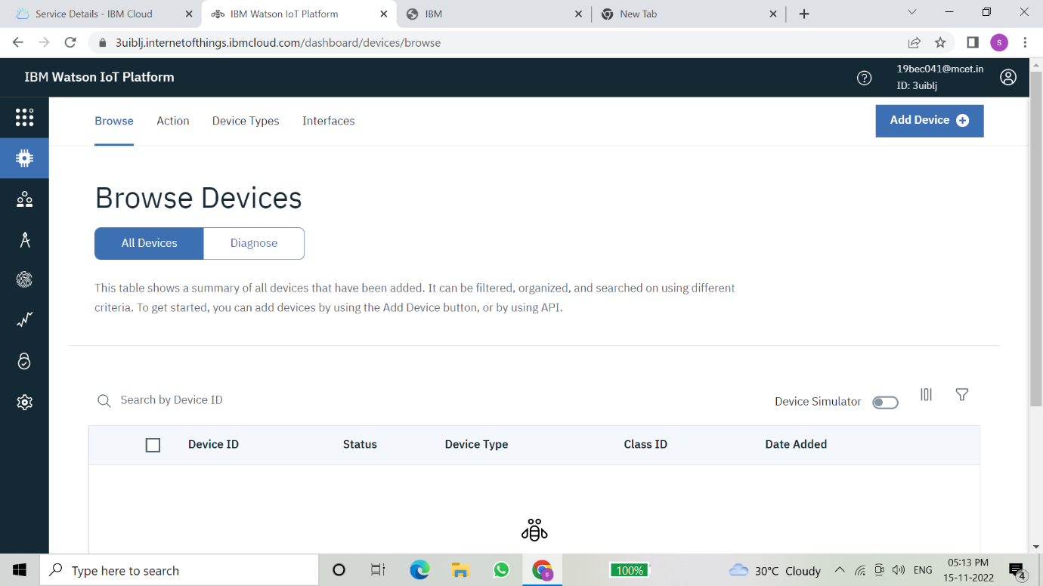

The setting tab is used to change the general setting if needed for the project

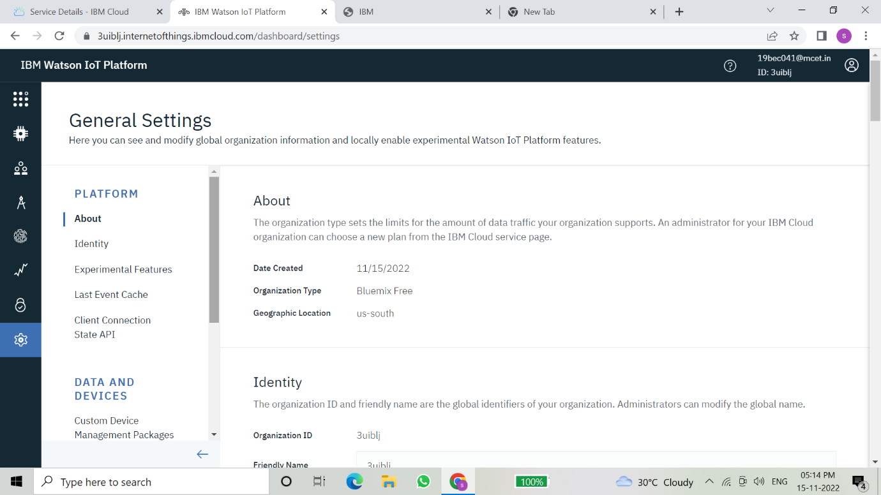

In the security tab we can choose the type of security connection and can change according to specification

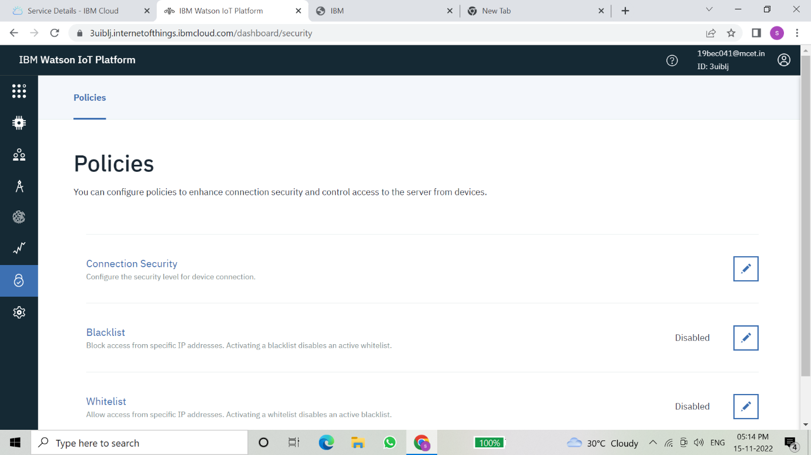

Usage gives the summary of how many bytes are used between the devices and the IBM cloud.

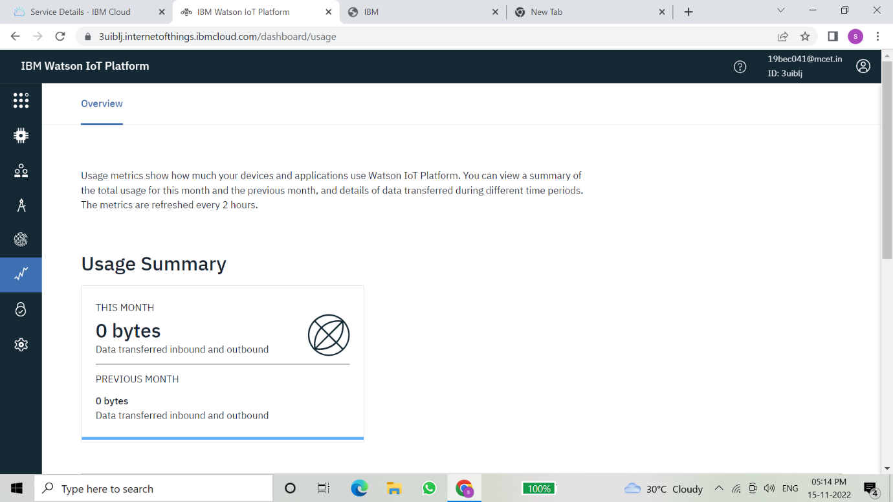

The member tab is add the teams members to work in the platform

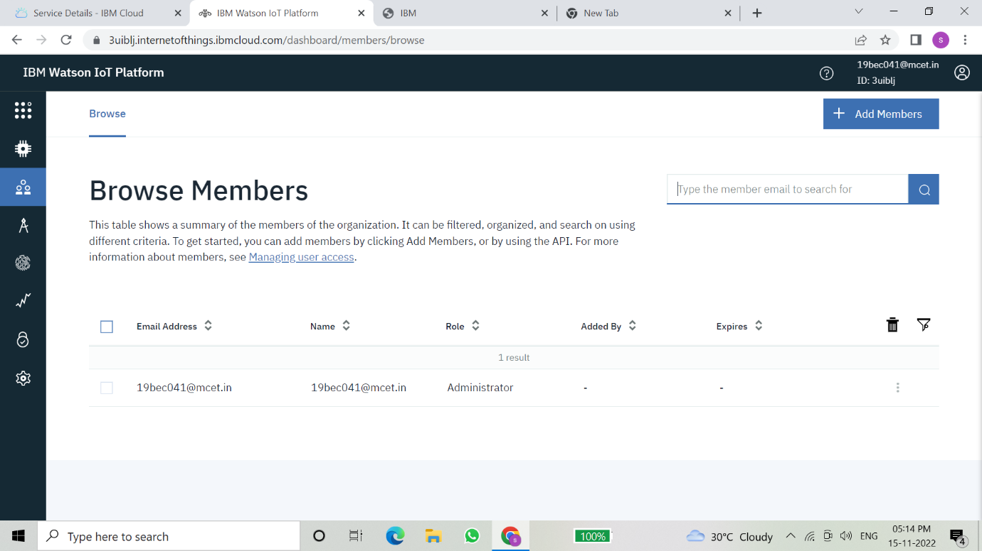

This tab is used when you want to connect to some other platform and to integrate with other services.

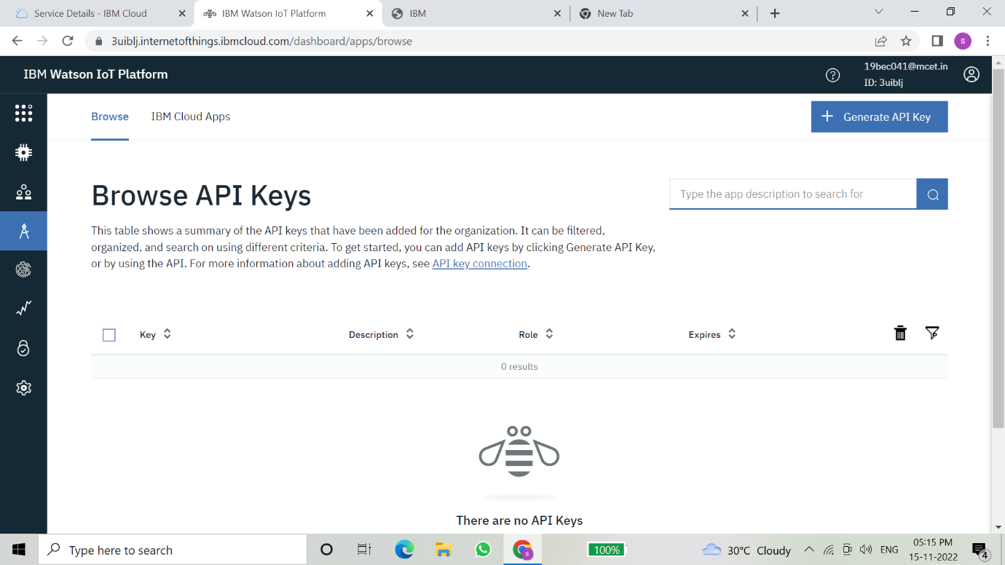

Click on the device tab and click on the add device button, then give the device type and device id and click next

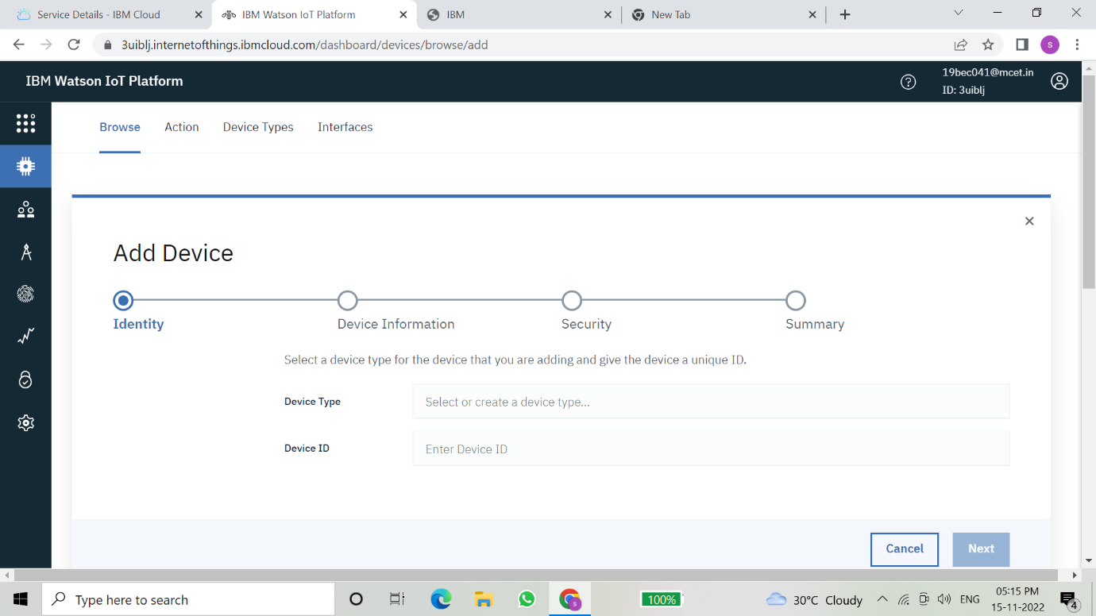

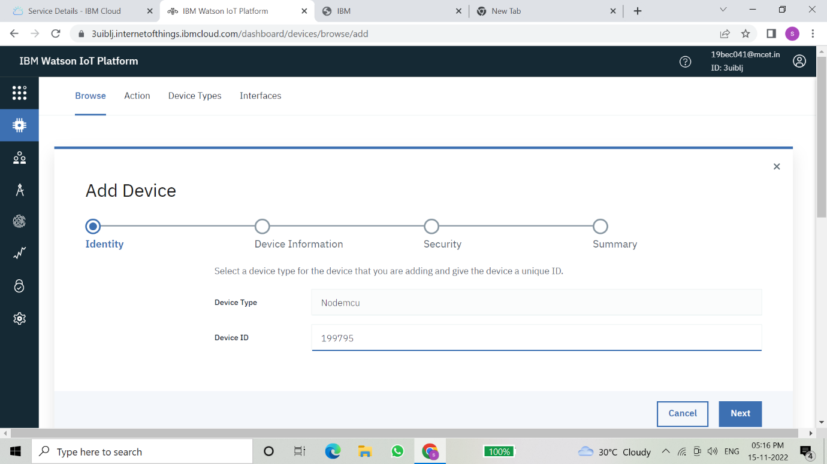

This page to enter extra details and of the hardware

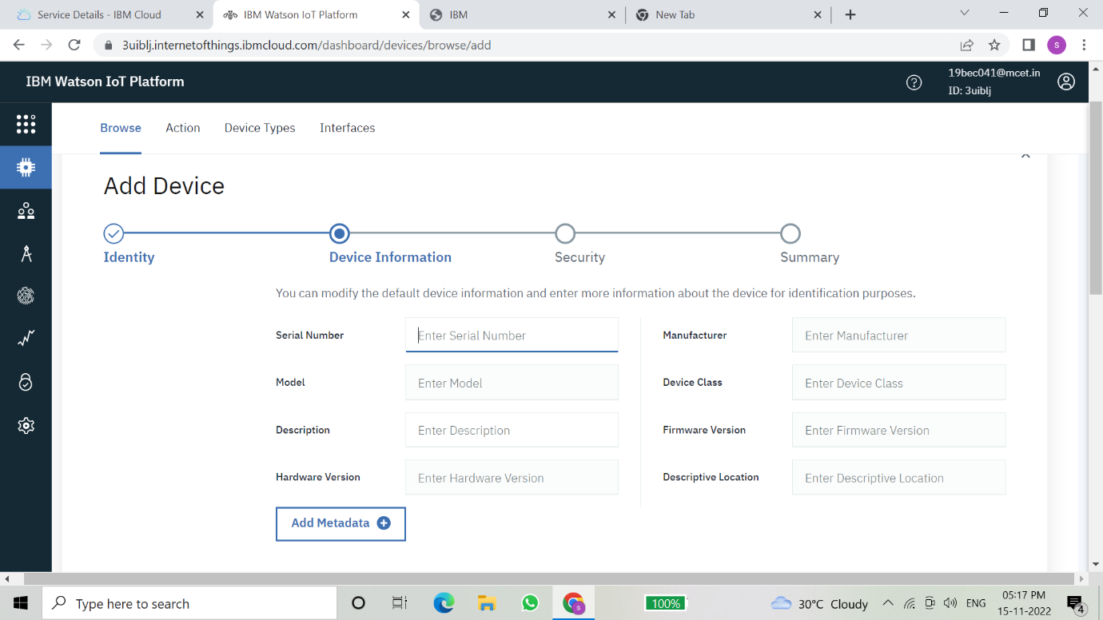

Clicking next it goes to the security where we do authentication token id.

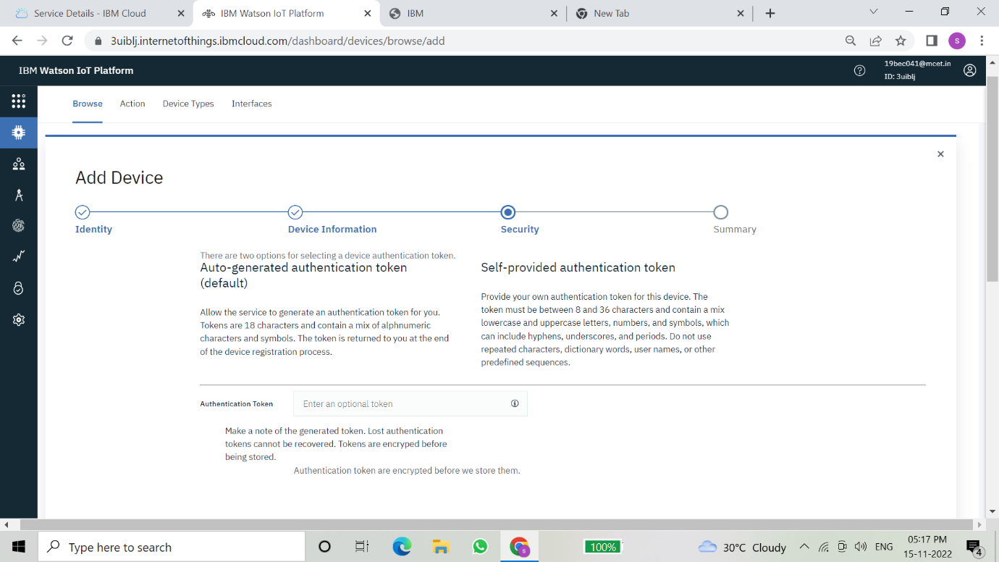

Clicking on next it goes to the summary of the device then click finish

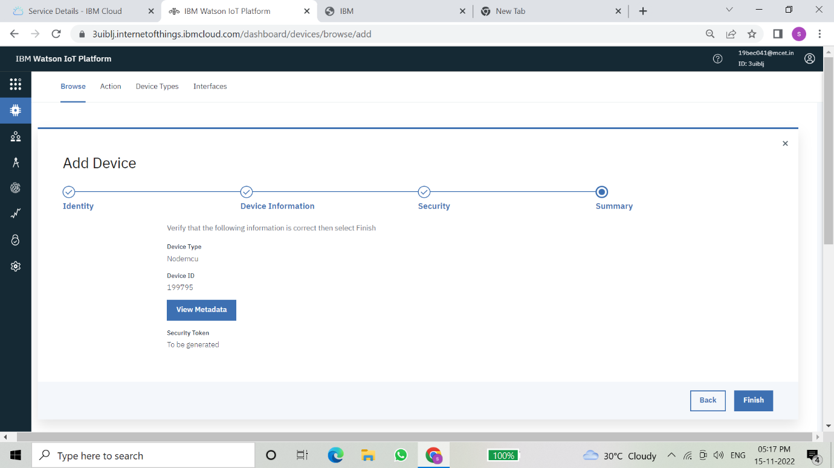

The device credentials will be displayed with all the details

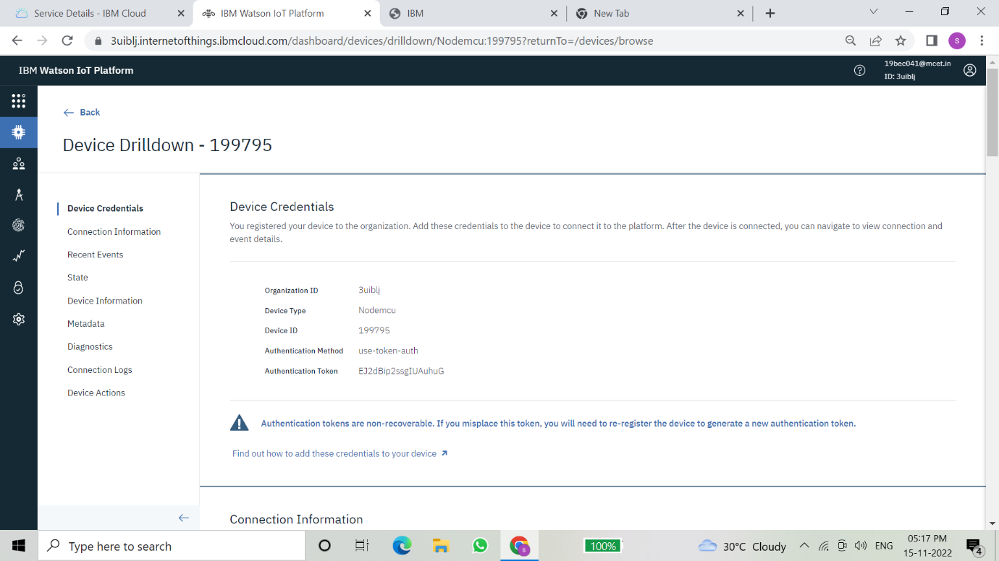

Safe the details of the device as the authentication tokens are nonrecoverable and if misplaced then we have to create a new one.

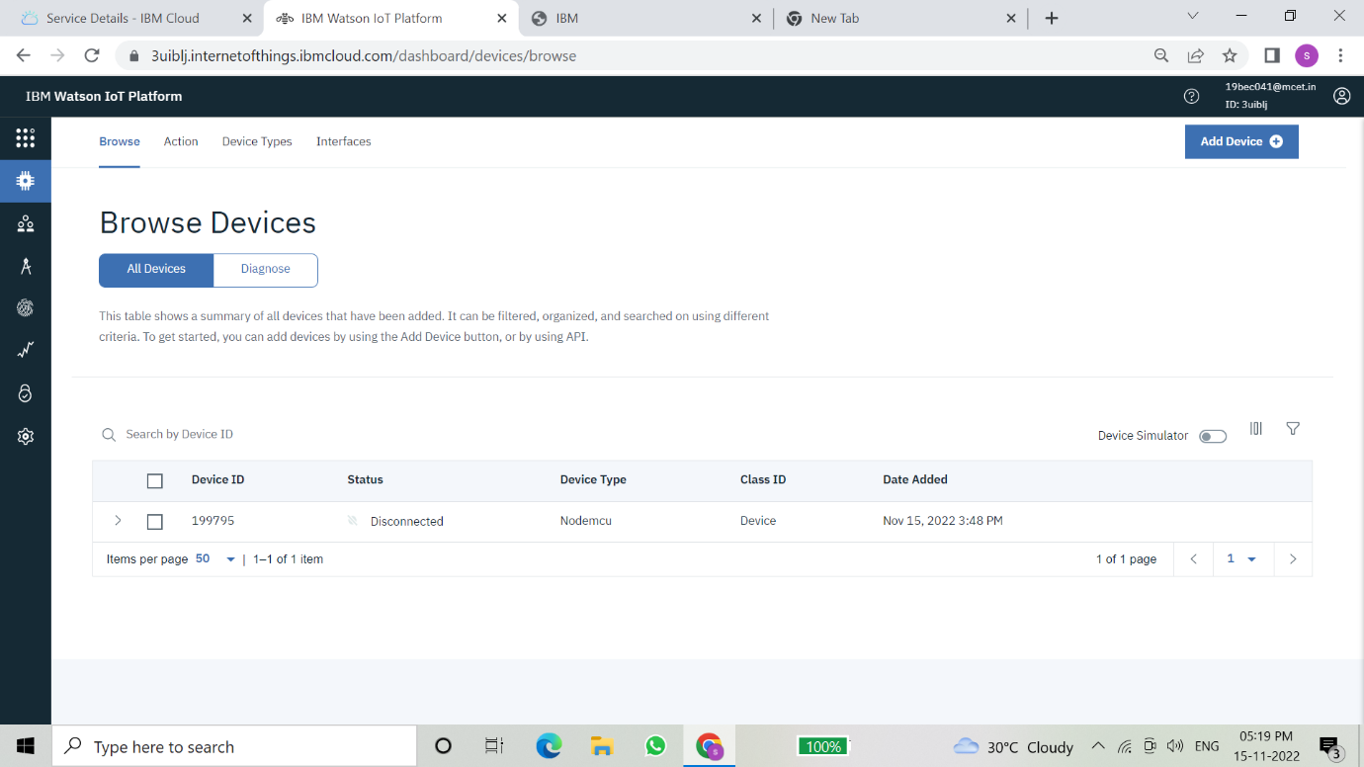

Clicking on the device tab we can now see the added device. Clicking on it will display the other details.

It has different tabs like Identity, Device Information, State and login

In a similar way, we can create n number of devices with a 50 per page limit as per the requirement of our project.

The Boards will display card for the project.

The Boards will display card for the project.

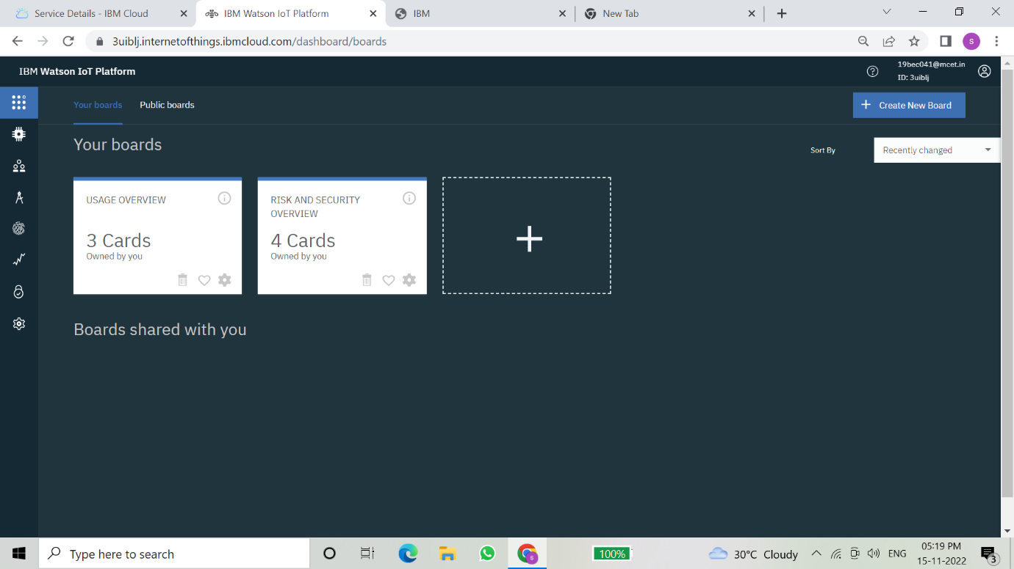

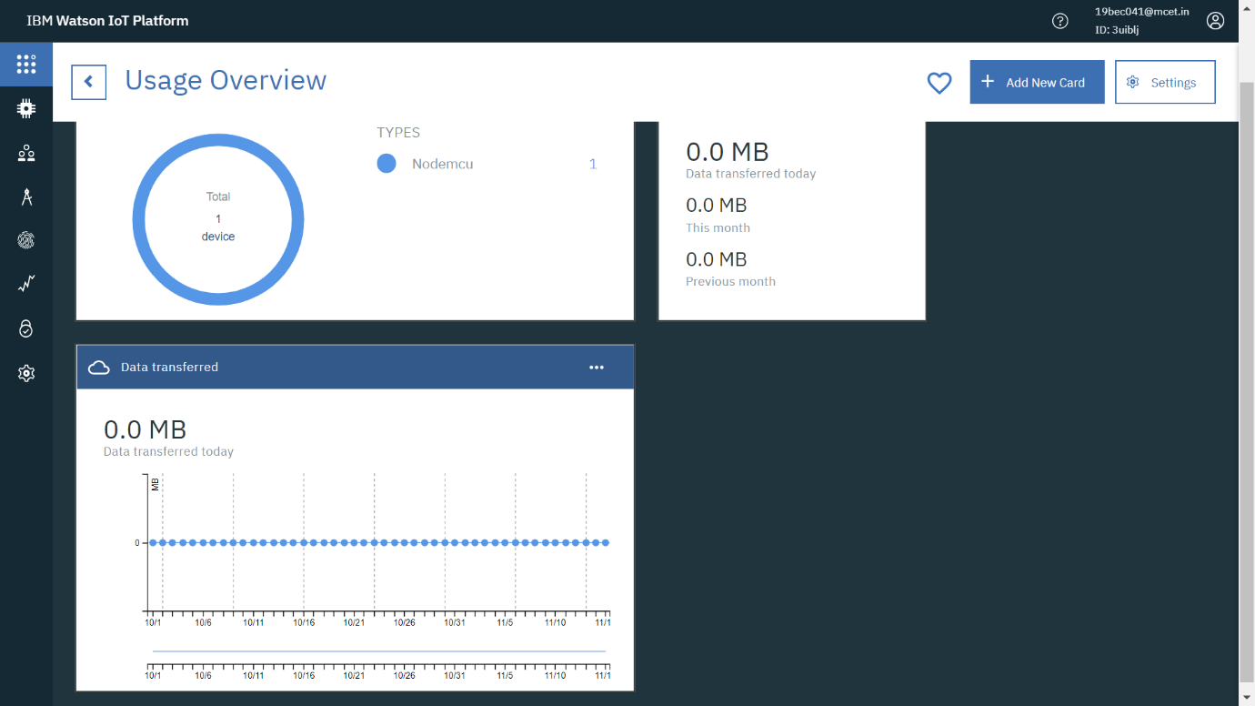

An IBM Watson cloud for IoT and a device is created